Accessibility Considerations for Web Mapping Applications

May 17, 2012

This document’s purpose is to illuminate for discussion the gray areas related to Accessibility and WCAG standards as they apply to Web Mapping applications.

**May 29th, 2012**

**QA team’s responses and recommendations are written in blue below the question.**

Contents

ALT Tags for the Main Map 1

ALT Tags in Mapping Symbology 3

Keyboard Navigation of Data Grid 4

Keyboard Navigation of Map 4

Keyboard Shortcuts for Info Windows 4

Data Grid Triggers 4

Submission Buttons 4

Help Documentation for Web Mapping Tools 4

# ALT Tags for the Main Map

WCAG states that all images should have an alt attribute describing the image. However, this is not something that is possible for the generated map image.

Images are generated at the server level, served out as tiles, and stitched together and presented as one image, though it is actually comprised of several. On our EcoGeo application, for example, the entire map is served as 12 tiled images, 6 representing the basemap…

**Recommendation: Use blank alt tags and** [**aria labeled-by**](http://www.w3.org/TR/wai-aria/states_and_properties#aria-labelledby) **for each tile in the base map**

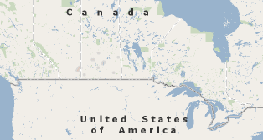**+**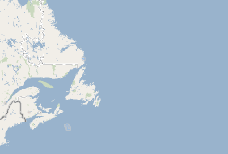

Six more representing the data overlay (Only displayed 2 here)…

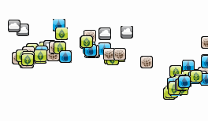**+** 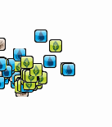

Example, showing image borders (there are more images than what is being outlined!):

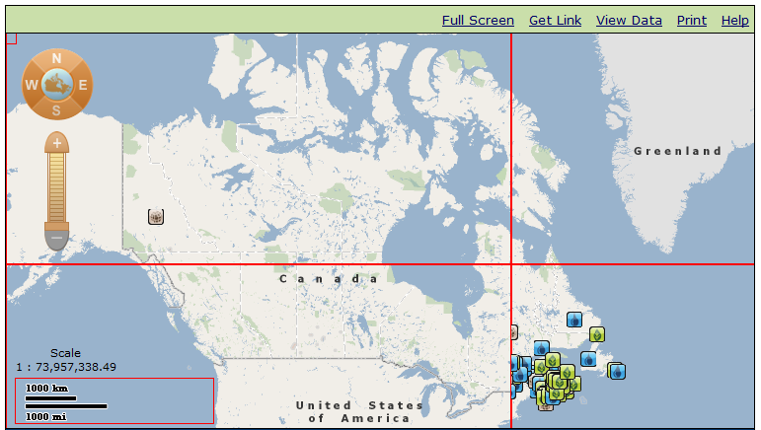

**The problem**: We are expected to provide alt tags on all images. However…

* Individually, these images have no context. Only taken as a collection are they meaningful.
* Symbology are SVG files compiled into tiled PNGs and then overlaid within the map div container. 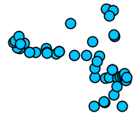
* These images are generated. We would need to write code to inject alt tags into the HTML after creation. This could have huge performance impacts if we need to inject alt tags every time the map adjusts.

**Recommendation: Use a data cache to cache regional information in advance on the server. Using an sql stored procedure that does basic region detection can dramatically speed things up. So for example, have a region grid, and pre-index all the locations inside that grid location. Then serve that list to the client, and the client can omit locations that aren’t applicable.**

**Some helpful links:**

[**http://en.wikipedia.org/wiki/Canadian_traveller_problem**](http://en.wikipedia.org/wiki/Canadian_traveller_problem)

[**http://www.youtube.com/watch?v=-0ErpE8tQbw**](http://www.youtube.com/watch?v=-0ErpE8tQbw)

[**http://en.wikipedia.org/wiki/Sorting_algorithm#Radix_sort**](http://en.wikipedia.org/wiki/Sorting_algorithm#Radix_sort)

[**http://stackoverflow.com/questions/3505864/loading-google-maps-markers-faster-dynamically**](http://stackoverflow.com/questions/3505864/loading-google-maps-markers-faster-dynamically)

* We were asked to provide alt tags for each point, which is not possible as they are not individual images when displayed on the page.

**Recommendation: Provide a longdesc and/or** [**aria-describedby**](http://www.w3.org/TR/wai-aria/states_and_properties#aria-describedby) **for the composited image that explains what the child images inside it are. But the accompanying datagrid should be sufficient, just explain to users that the info is available there**

* What options are available to us in order to secure a “pass”?

# ALT Tags in Mapping Symbology

The problem: we have received mixed responses on what is expected regarding ALT tagging the images used to represent points on the map, but outside the context of the map itself.

Symbology in the legend:

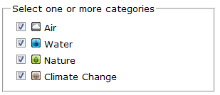

Symbology in the map tip:

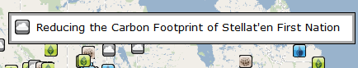

Symbology in the “Quick Info” pane:

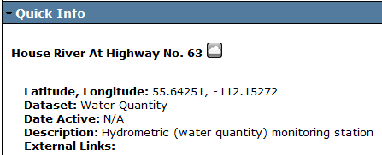

**The problem**: How do we handle ALT tags on these “legend images”?

* In the above legend example, how would you describe the ALT tag? “Image of cloud”? “Image of cloud representing ‘Air’” (bearing in mind that the “Air” label follows the image in the legend already?)?

**The alt tag is supposed to say what the purpose of the image is. What it is a picture of is a secondary consideration. In this case, the “cloud” icon alt text should be “item in the air category”. However,**

**As the legend is already labelled, the alt text would result in duplication.** [**H2: Combining adjacent image and text links for the same resource**](http://www.w3.org/TR/WCAG20-TECHS/H2.html)**. “The objective of this technique is to avoid unnecessary duplication that occurs when adjacent text and iconic versions of a link are contained in a document. “**

**Suggestion: load the image into the legend through css, and no alt text is necessary.**

Similarly, when using the image in other areas other than the legend, what should the ALT tag be? “Image of cloud”? “Image of cloud representing ‘Air’”?

**Recommendation: Should describe what it is representing “Air Category” Not the literal description**

* When the same image is presented multiple times on a page, can it use different ALT tags depending on context?

**Recommendation: Icons should have the same alt text everywhere.**

**The point id as well as the category the icon is representing.**

**This following only applies to the map. Icons inside of dialogs and text blocks (such as the “quick info pane”) wouldn’t apply. It is recommended for html 5 and ARIA. It shows a method using <figure>, <figcaption> img and alt and descriptions.**

**Scroll down the page to the section “Figures in Web Pages”**

**http://www.sitepoint.com/real-world-accessibility-html5-aria-and-the-modern-web/#fbid=tYgx_EZG7Fa**

**<figure>**

**<img src="../blocklinksvoiceover-500-2.png"**

**alt="Screenshot of block links with Voiceover on the Mac."**

**aria-describedby="figcaption1">**

**<figcaption id="figcaption1">**

**<strong>Screenshot</strong>: We use block links on the promo page...**

**In other screen readers, parts of the link aren’t read at all.**

**</figcaption>**

**</figure>**

# Keyboard Navigation of Data Grid

We have done a lot to make our mapping applications navigable by keyboard. However, there are limitations on how much we can do.

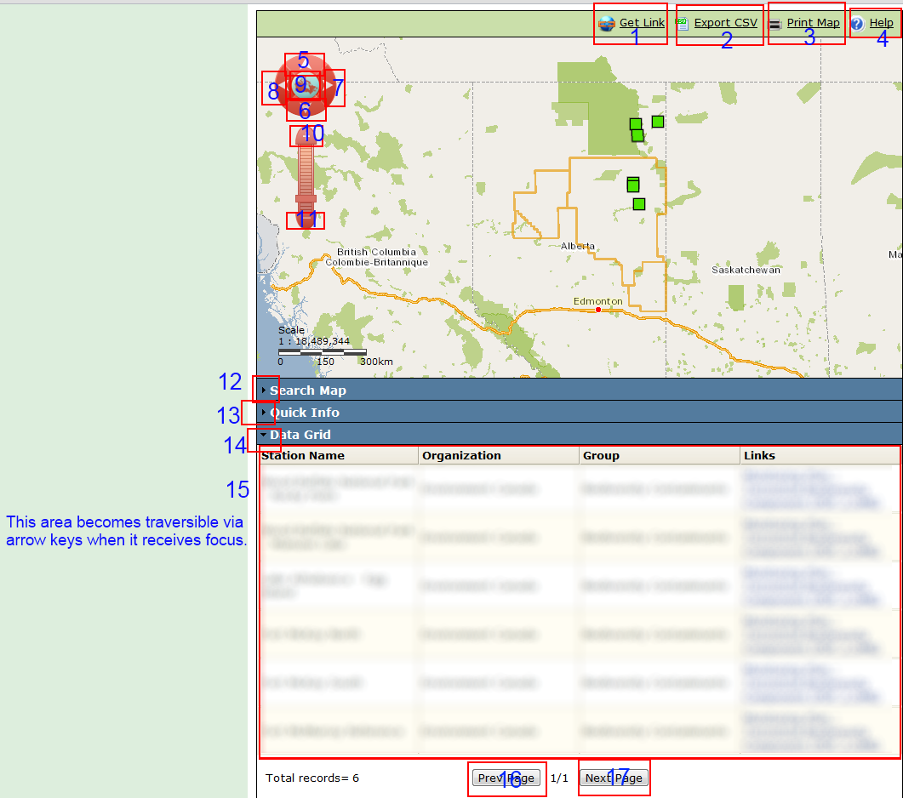

As the screenshot suggests, tab index will bring you from the toolbar at the top of the map, down through the navigation elements, through the collapsible containers, and into the data grid. Once the data grid receives focus from tabbing, pressing Tab again will jump you to the data grid pagination buttons at the bottom. While in focus, the data grid cells can be traversed by arrow keys and using Enter to select a row.

**The problem**: Inconsistency on strategy for handling keyboard navigation.

* Is what we’re doing suitable? If not, why not?

**Mostly yes.**

**Recommendation: Since the user won’t know what part uses arrow keys and what doesn’t, just put an explanation at the top of the page explaining when to use arrow keys and when to use tab key.**

**There were a couple small browser dependant bugs where the keys didn’t work correctly, but that is more a coding issue, than an accessibility issue.**

* Should the users be able to tab through everything, including every cell of the data grid?
  + If the application were to function this way, the user would need to tab through over 40 elements to get through the data grid!

**Recommendation: bypass blocks. You can either use same page links that skip sections, or have proper nested headings <h1>, <h2>, etc. AT should be able to handle either method.**

**If the page is long and full of content, using filters to reduce what the user will want to view will cut down on the number of links**

**The following** [**Google Maps**](http://googlemaps.pentia.dk/en/Map5.aspx) **example also uses filtering so as to reduce links and content. This example uses a product to help produce accessible maps but I assume this can be done without this product, so I am providing as it shows how they make these kinds of maps accessible**

# Keyboard Navigation of Map

EcoGeo is our only application that grabs keyboard focus when the map is selected. On the bottom right of the map, an image displays notifying the user that arrow keys and plus/minus keys will now pan and zoom the map :

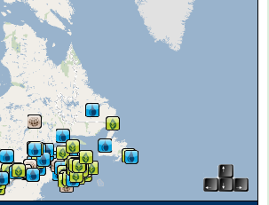

**The problem**: We would like to roll this feature into our other applications, but is it a best practice?

**This alone won’t work for people with low vision, blindness, or learning disability.**

**Recommendation: You also need a text description at the top of the page (you can use expand/collapse if you want to conserve screen space).**

**It seems the** [**WET example**](http://alpha.gcwwwtemplates.tbs-sct.ircan.gc.ca/theme-clf2-nsi2/geomap-eng.html) **uses just the minus to zoom and left and right. It is also covered** [**here**](http://www.sitepoint.com/real-world-accessibility-html5-aria-and-the-modern-web/#fbid=tYgx_EZG7Fa) **using ARIA.**

# Keyboard Shortcuts for Info Windows

On our JavaScript applications often use what is called a “map tip” (an information pane that is displayed when hovering over a map feature) or an “info window” (a similar information pane that is activated by selection). Our usage of these have been basic, but recent innovations in the ESRI library present more versatile and feature rich info windows.

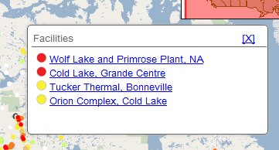 vs. 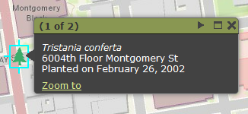

Our current info window vs. the new “popup” from ESRI

**The problem**: How can we make these keyboard accessible? How do we inform the users of these shortcuts?

**Recommendation: Use ARIA.** [**http://www.w3.org/TR/wai-aria/**](http://www.w3.org/TR/wai-aria/) **. If you visit the IRCAN WET page, they have all the aria markup needed for dialog UI features.**

* Keypress “X” or “ESC” to close a window?
* Left and right arrow keys to traverse records?
* Collapse/Maximize keyboard shortcuts?
* Zoom to?

**Provide a text explanation at the top (you can use expand/collapse if you want to conserve screen space).**

# Data Grid Triggers

We would like some guidance on best practices for our data grid functionality. The default “Out of the box” behaviour from the ESRI API is to zoom the map to the selected row of the data grid. Anywhere on the row can be selected:

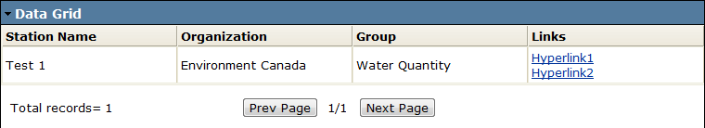

**The problem**: We lack consistency in how we handle our data grids and would like a common approach that is accessible to our users.

* In the case of the above screenshot, hyperlinks open new windows/tabs to other web pages.

**As long as you let the user know it goes to a new page, this is ok.**

* Default behaviour of this is to also zoom into the point.

**Instead of having the user click anywhere in the data grid and it zoom, perhaps have a button in each** **row that has a title or label that lets the user know what will happen when they click it. This will be easier for all people, not just disabled people.**

**Assume that is what the hyperlink 1 does, so need to describe what the link actually is anyway**

* When the row is selected, and the map zooms to the point, the contents of the data grid are modified to reflect only the data points found within the zoomed in extents of the map.

**Perhaps have a refresh button that updates the datagrid to reflect the new location on the map.**

**Just need to explain the refresh button – give it a meaningful name**

* When the hyperlink is clicked, a new tab opens. When the user returns to the map, they will then notice they’ve been zoomed in.
* Is this acceptable? If not, what is the preferred way to handle this?

**See above. Try to make UX interaction as predictable as possible. If you want to let the user do something they might not know they can do, give them advanced warning using either text, labels, titles, or other semantic markup.**

One option we are considering:



In this example, the first hyperlinked row would be the link to zoom. Selecting the rest of the row would not fire any events. The Hyperlink1 link would open in a new tab. Is this a good practice?

# Submission Buttons

Our mapping applications typically have a number of form inputs to drive control of the map:

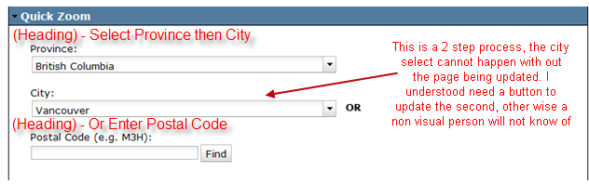

**Recommendation: Notify the user that one action will affect a change, through a quick sentence above the box**

**The Problem**: Lack of consistency in how we handle our forms on maps.

Probably a simpler issue to answer:

* Do these forms require Submit buttons?
* Due to the asynchronous nature, we often drive data using the onChange event of a dropdown.
* Is this acceptable, or should a selection be made in the dropdown first, and a submit button following after (such as the postal code box above)?
* What about togglable layers (checkboxes?):

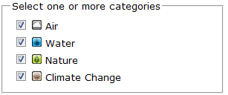vs 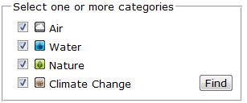

**Recommendation: Submit button is not necessary in this situation but please review 3.2.2 (SCR19) of the standard.**

# Help Documentation for Web Mapping Tools



* What are the best strategies for documenting how to understand the nuances of accessible web mapping?

**Recommendation: Be a simple, concise, and complete as possible. Use short words, no acronyms if possible, and focus on completeness and brevity as opposed to long winding descriptions. Take each statement, and ask yourself: Am I saying this in the fewest number of words possible without omitting necessary information?**

* Currently we have a generic help document detailing the attributes of our web mapping applications, and their usage.
* Can we extend this to include keyboard navigation, external link disclosures, drawing/editing widgets, any function of the page that might require an explanation as to how to use it?

**Recommendation: Yes.**

* The alternative: Including help documentation alongside the tool, ie. By way of tooltip, inline documentation, alt tags?

**Recommendation: Inline documentation is always helpful. It may be helpful to review how** [**Corporations Canda**](https://www.ic.gc.ca/app/scr/cc/CorporationsCanada/bs/crp-wz.html?act=6) **site handles these issue**